

**UNDERWRITING BULLETIN**

|  |  |  |
| --- | --- | --- |
| **To:** |  | **All Florida Agents of WFG National Title Insurance Company** |
|  |  |  |
| **From:** |  | **WFG Florida Underwriting Department** |
|  |  |  |
| **Date:** |  | **April 23, 2013** |
|  |  |  |
| **Bulletin No.:** |  | **FL 2013-06** |
|  |  |  |
| **Re:** |  | **Buckingham Funding Trust** |

Effective immediately, prior written approval of the Underwriting Department is necessary for any transaction involving:  
  
**Entity:**  
  
Buckingham Funding Trust  
  
**Property:**  
  
3904 SE Fairway East, Stuart, FL 34997; Parcel ID 37-38-41-011-000-01060-8  
Lot 106, Yacht & Country Club of Stuart, Plat Book 4, Page 72, of the Public Records          
of Martin County, FL

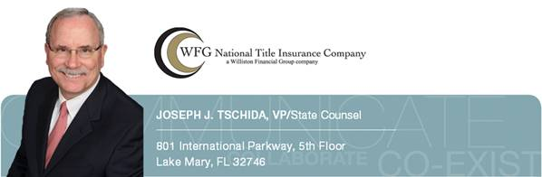

P: (407) 562-1946 | D: (407) 562-1267 | C: (407) 399-7553  
Web: [www.wfgnationaltitle.com](http://www.wfgnationaltitle.com/)

NOTE: This Bulletin should not be interpreted as reflecting negatively upon the character of an individual or entity and is for the sole purpose of establishing underwriting positions reflecting WFG National Title Insurance Company’s best business judgment.  The information contained in this Bulletin is intended solely for the use of employees of WFG National Title Insurance Company and its agents.  Disclosures to any party not described above are prohibited unless approved in writing by the WFG National Title Insurance Company’s Underwriting Department.